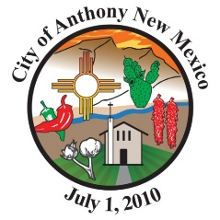
2025-0XX
A RESOLUTION ADOPTING THE FINAL BUDGET FOR FISCAL YEAR 2025-2026 FOR THE CITY OF ANTHONY, NEW MEXICO.
WHEREAS, the Governing Body of the City of Anthony, New Mexico, a New Mexico Municipal Corporation (hereinafter referred to as the “City”) has developed a budget for fiscal year 2025-2026; and
WHEREAS, said budget was developed on the basis of need and through cooperation with all user departments, elected officials, and other departments supervisors; and
WHEREAS, it is the majority opinion of the Governing Body of the City of Anthony, New Mexico that the proposed budget meets the requirements as currently determined for Fiscal Year 2025-2026.
NOW THEREFORE BE IT HEREBY RESOLVED that the Governing Body of the City of Anthony, New Mexico, hereby adopts the final budget here in above described and respectfully request approval from the local Government Division of the Department of Finance and Administration.
PASSES, ADOPTED AND APPROVED THIS 16TH DAY OF JUNE 2025.

_____________________________
Diana Murillo, Mayor

{SEAL}
Attest:
______________________
Karla Oropeza, City Clerk

ROLL CALL VOTE:
MPT Holguin YES NO ______________________________________
Trustee Garcia YES NO ______________________________________
Trustee Barreras YES NO ______________________________________
Trustee Herrera YES NO ______________________________________

